|  |  |  |
| --- | --- | --- |
| **Positron Annihilation Spectroscopy Facility in KAERI**  **Jaegi Lee1*, Young Rang Uhm1, Gwang-Min Sun1, Young-Su Jeong1,2, Junyoung Lee1,3, Seong-Ueoll Baek1**  1Korea Atomic Energy Research Institute, Republic of Korea  2Daegu Catholic University, Republic of Korea  3Seoul National University, Republic of Korea  *E-mail: jgl@kaeri.re.k |  |  |

**Keywords:** Positron Annihilation Lifetime Spectroscopy (PALS), Coincidence Doppler broadening Spectroscopy (CDBS), Free volume, Defect, Electron momentum

Positron annihilation spectroscopy (PAS) is a powerful tool to measure the lattice defect of materials. Positron annihilation lifetime spectroscopy (PALS) can distinguish the defect distributions in the samples, and coincidence Doppler broadening spectroscopy (CDBS) analyze the electron affinity of the positron, which is related to the electron momentum information. Korea atomic energy research institute (KAERI) operates a radioisotope-based PAS facility for PALS and CDBS. Also, KAERI has a plan to build a reactor-based PAS facility using the HANARO research reactor. In 2020, several polymer, metal alloy and semiconductor samples were analyzed using PALS and CDBS. In order to measure the free volume of the polymer samples, the longest positron lifetime component about 2 ns caused by *ortho*-positronium was analyzed using PALS. The positron lifetime of poly(ethylene terephthalate), polyimide and polyamide samples were measured. For metal alloy, the reduced activation ferritic–martensitic alloys (RAFM), cast steel and AlMgSi aluminum alloy were analyzed to measure the size and amount of defects. Among the metal alloy samples, *in-situ* PALS has been operating to measure the natural aging effect of the aluminum samples. Moreover, GaN power semiconductor and RAFM samples has been loaded on the CDBS facility.

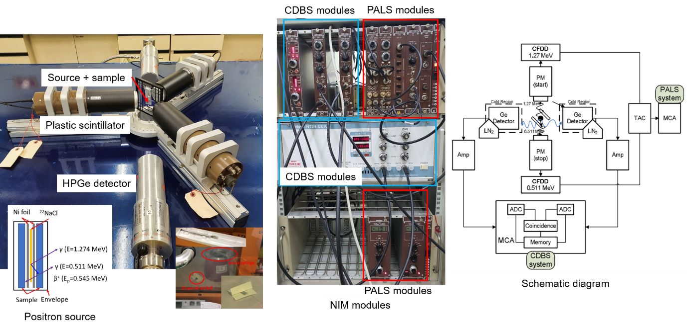

Fig. 1. Positron annihilation spectroscopy facility in KAERI

Acknowledgement

This work was supported by the National Research Foundation of Korea (NRF) Grant funded by the Korea government (MSIT) (NRF-2017M2A2A6A05018529).